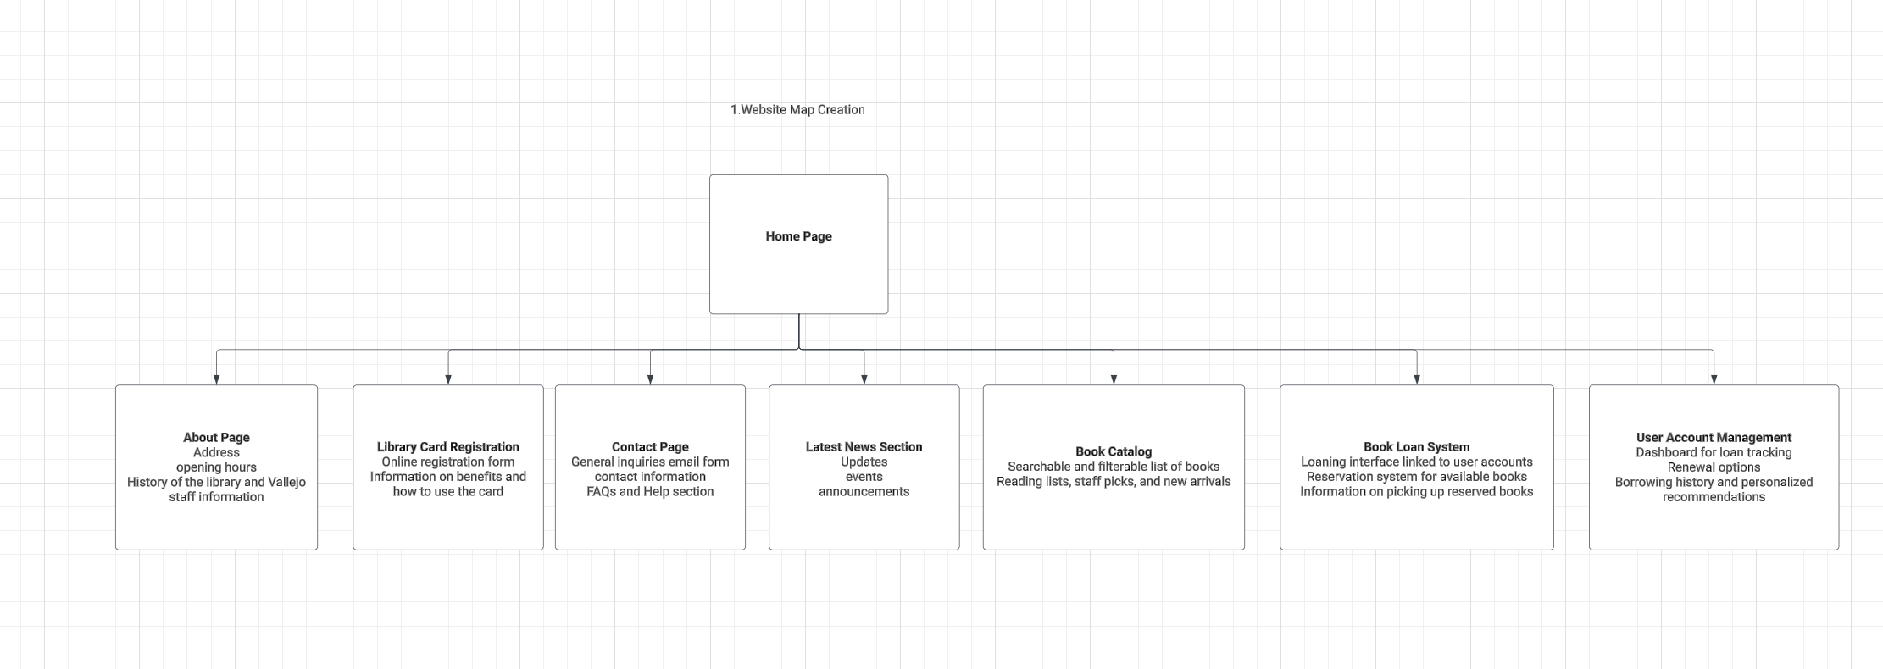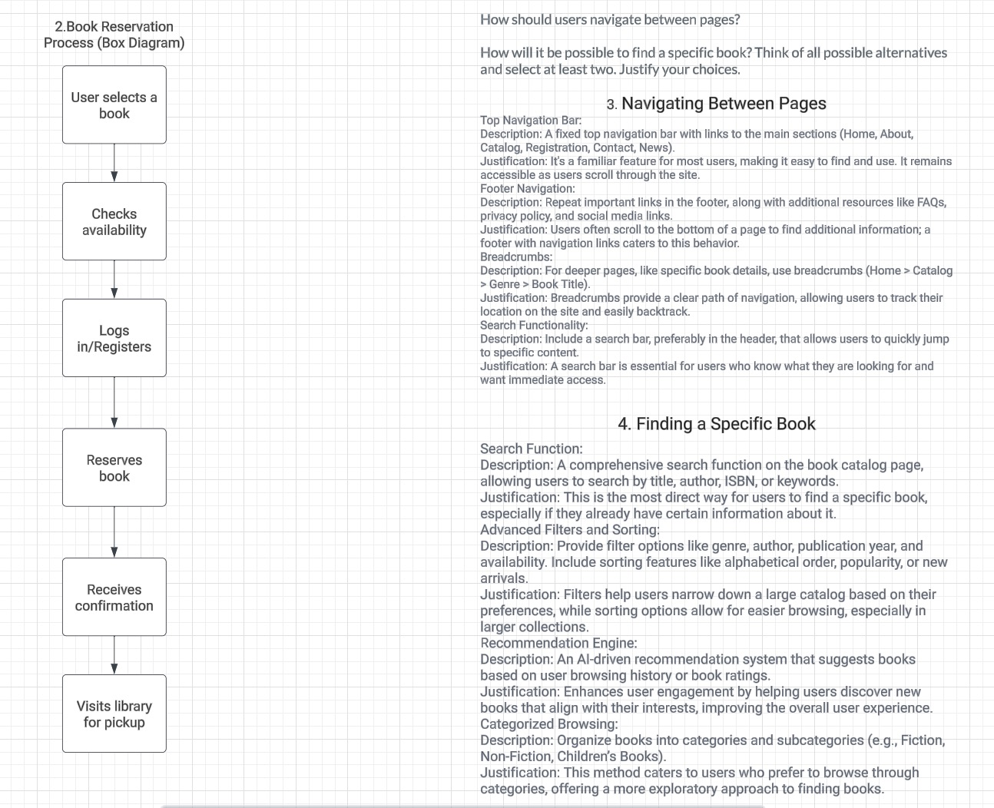

https://github.com/jiabeiliu/INFO6150-Module-3-Assignment-Planning-a-website-.git